Dear Church Family and Friends,

You may have heard I was appointed to Island Heights UMC in Island Heights, NJ, as of July 1, 2024. That means you will be receiving a new pastor. I know that you will welcome them with open arms and loving hearts.

You may ask why the move? In the United Methodist Church, when one agrees to become a pastor, we agree to the Itinerant System of Pastoral Leadership.
According to the Resource UMC Website, “When people new to United Methodism hear “Itinerancy” refers specifically to the commitment by pastors to go and serve wherever their bishops send them. “Appointment” is the action taken by bishops. These are different, yet related…Before they are ordained or licensed, clergy in The United Methodist Church agree to serve where their bishop appoints them. Appointments are for one year at a time. For elders and local pastors, particularly, the goal is to match the gifts and graces of the particular Pastor with the ministry needs of a particular congregation. In this “serial leadership” of consecutive pastors – no two are alike – over time, the combination of skills blends to form a broad base of developed ministries. —Adapted from “Chuck Knows Church,” Discipleship Ministries, and the General Board of Higher Education and Ministry website.

This call to a change in Pastorate comes as a bit of a surprise; however, I trust the process and trust that God is raising the next Pastor to lead the congregations of MRUMC and LUMC into the next part of the ministry journey serving the hearts of the people and the community.

I will be here and be your Pastor until the last day of June. Between now and then, let us continue to focus on spreading God’s love, serving God’s children, and making disciples of Jesus Christ for the transformation of the World. Bob and I will forever be grateful for your love and for making our time together memorable.

With much love and grace,
Pastor Karen

Isaiah 6:8 CEB 8 Then I heard the Lord’s voice saying, “Whom should I send, and who will go for us?” I said, “I’m here; send me.”

March Birthdays:

1 Betty Adams
5 Terrance Gilbert
8 Wendy Smith
9 Janice Clark
12 Ned Johnson
13 Barbara Golden
20 Shirley Bootsma
20 Christine Benson
24 Nancy Everham
25 Elizabeth Zimbleman

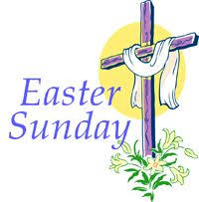
April Birthdays:

4 Brian O’Donnell
19 Rita Golden
21 Bonnie Hastings

Dates To Remember 2024

March 10 – UMCOR Sunday

March 24 - Palm Sunday

March 28 - Holy Thursday
Worship Services - Noon & 7:00PM ( MRUMC )

March 29 - Good Friday
Ecumenical Service - 1st Presbyterian Church
Mt. Holly, NJ 12:00-3:00 PM
Worship Service 7PM (MRUMC)

March 31 - Easter Sunday
Worship Services: 7AM & 9:30AM (MRUMC)
11:00AM (LUMC)

April 14 - Native American Ministries Sunday

May 12 - Ascension Sunday / Festival of the Christian Home / Mother’s Day

May 19 – Pentecost Heritage Sunday

May 26- Trinity Sunday /Peace with Justice Sunday

June 16 - Father’s Day

Oct. 6 - World Communion Sunday

Oct. 20– Laity Sunday

Oct. 27- Reformation Sunday

Nov. 3 - All Saints Sunday

Nov. 24 - Christ the King Sunday

Dec. 3 - 1st Sunday in Advent

Dec. 24 – Christmas Eve
Worship Services: MRUMC - Noon & 6:30PM
LUMC 4:00PM

Dec. 25 – Christmas Day

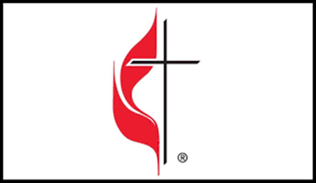

Lent Sermon Series: “Giving It Up”

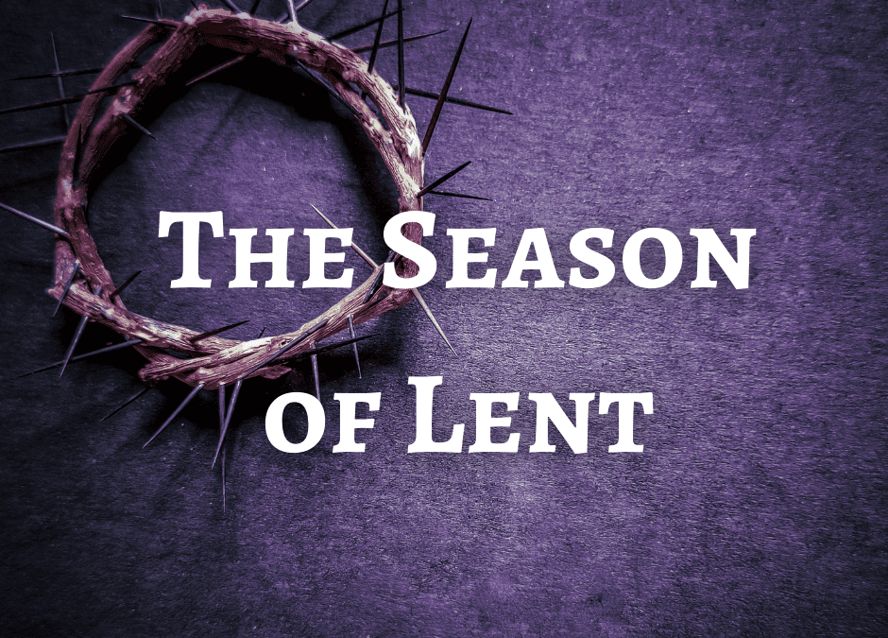

3/3/2024 - “Giving Up Superiority” - John 4:5-42

3/10/2024 -“Giving Up Enemies”- Luke 19:37-44

3/17/2024 - “Giving Up Our Lives”
Ezekiel 37:1-14; John 11:1-45

3/24/2024 – “Giving Up Popularity” (Palm Sunday) Matthew 21:1-11

3/31/2024 – “Giving Up Death” (Easter Sunday)
Acts 10:34-43; John 20:1-18

Special Holy Week Opportunities:

March 28, 2024 - Holy Thursday

Worship Services with Communion
12:00 Noon & 7:00PM (MRUMC)

March 29, 2024 - Good Friday

Ecumenical Good Friday Service - 12:00-3:00PM
First Presbyterian Church
125 Garden St. Mt. Holly, NJ
Worship Service 7:00 PM (MRUMC)

March 31, 2024 - Easter Sunday Services

7:00 AM - Sunrise Service MRUMC
8:00 AM - Breakfast
9:30 AM - Worship Service MRUMC
11:00 AM – Worship Service LUMC
(Lite Refreshments to Follow)

