April 30, 2023
9:30 AM Worship Service
Fourth Sunday of Easter

*Musical Prelude:
Welcome and Announcements

Call to Worship: Lay Reader: Bob Murray
L: Though the way seems long and the road rough
P: Yet will we trust the One who leads us.
L: Though the direction is unknown and we don’t know the outcome
P: Yet will we place our lives in Christ’s loving care.
L: It is Christ who brings us out to green pastures and restores our souls.
P: It is Christ who gives us hope and peace. Praise be to Christ our Lord. AMEN.

Song of Praise: Great Is the Lord TFWS #2022
Refrain:
Great is the Lord, he is holy and just; by his power we trust in his love.
Great is the Lord, he is faithful and true; by his mercy he proves he is love.

Great is the Lord and worthy of glory! Great is the Lord and worthy of praise.
Great is the Lord; now lift up your voice, now lift up your voice:
Great is the Lord! Great is the Lord!

Great are you, Lord, and worthy of glory!
Great are you, Lord, and worthy of praise.
Great are you, Lord; I lift up my voice, I lift up my voice:
Great are you, Lord! Great are you, Lord!

Opening Prayer:
We are standing at the gate, O loving Shepherd, not sure about the journey. But you have called our names, and in your voice we hear such love and surety. Bring us safely on the journey and strengthen us that we may serve you in all that we do. AMEN.

Opening Hymn: Come, Thou Fount of Every Blessing UMH #400
Come, thou Fount of every blessing, tune my heart to sing thy grace;
Streams of mercy, never ceasing, call for songs of loudest praise.
Teach me some melodious sonnet, sung by flaming tongues above.
Praise the mount! I’m fixed upon it, mount of thy redeeming love.

Here I raise mine Ebenezer; hither by thy help I’m come;
And I hope, by thy good pleasure, safely to arrive at home.
Jesus sought me when a stranger, wandering from the fold of God;
He, to rescue me from danger, interposed his precious blood.

O to grace how great a debtor daily I’m constrained to be!
Let thy goodness, like a fetter, bind my wandering heart to thee.
Prone to wander, Lord, I feel it, prone to leave the God I love;
Here’s my heart, O take and seal it, seal it for thy courts above.

Prayer of Confession:
Patient and loving God, we stand at the gate and peer through. We keep creating our own ways, believing that we know what is in our own best interest, and we ignore the voice of the one Shepherd who will guide us to peace and hope. We wander aimlessly and then wonder why we get so lost. Help us stop and listen to the Shepherd’s voice. Let us place our trust in the Shepherd who has never failed us, who loves and guides our lives. Forgive us our stubbornness and stupidity. For we ask this in Christ’s Name. AMEN.

Words of Assurance:
Even though we have wandered and have become lost, the shepherd calls to us. We can place our trust in his loving care. For we are the sheep of his pasture, blessed and given hope. AMEN.

Passing of the Peace
Wiggle Time/Noisy Coins/Offering:

Doxology: UMH #95
Offertory Prayer:

Prayer Chorus: More Precious than Silver TFWS #2065
Lord, you are more precious than silver.
Lord, you are more costly than gold.
Lord, you are more beautiful than diamonds,
And nothing I desire compares with you.

Pastoral Prayer:
The Lord's Prayer:

Song of Preparation: Be Still, My Soul UMH #534
Be still, my soul: the Lord is on your side.
Bear patiently the cross of grief or pain;
Leave to your God to order and provide;
In every change God faithful will remain.

Be still, my soul: Your God will undertake
To guide the future, as in ages past.
Your hope, your confidence let nothing shake;
All now mysterious shall be bright at last.

Be still, my soul: the hour is hastening on
When we shall be forever with the Lord,
When disappointment, grief, and fear are gone,
Sorrow forgot, love’s purest joys restored.

Scripture: 1 Peter 2:19-25
Sermon: “Guardian of Your Souls” Rev. Karen Murray

Closing Hymn: Lord, I Lift Your Name on High TFWS #2088
Lord, I lift your name on high; Lord, I love to sing your praises.
I'm so glad you're in my life; I'm so glad you came to save us.

You came from heaven to earth to show the way,
From the earth to the cross my debt to pay;
From the cross to the grave, from the grave to the sky;
Lord, I lift your name on high. (Repeat)

Benediction

Sending Forth: Go In Love
Go in love. Have no fear, God will guide you, He is always near.
Go in love. Take his hand. God will hear you, He will understand.
May his light forever shine upon you; May his peace be always in your heart.
Go in love, face each day. God will lead you, He will show the way.
Go in love and live in faith. Amen.

Postlude

Last week’s offering received: $335.00 In person attendance last week: 41

Masonville & Lumberton Men - "1st Sunday of the Month"
Men's breakfast - at Masonville on May 7, 2023

We are off to a great start with the Men's Breakfasts! We've covered many topics from God's blessings, drawing strength from God, Artificial Intelligence, and Robots!
7:45 am - Gather in Fellowship Room, Coffee.
8:00 am - Opening prayer, light breakfast and fellowship
8:15 am - Devotional topic and discussion
9:00 am - Adjourn

Thank you!
Greg Scott 609-280-9539
Masonville-Rancocas United Methodist Church
200 Masonville Rd.
Mt. Laurel, New Jersey 08054
(856) 234-0941

"We are a Christ-Centered Church reaching out to the world transforming lives for the Glory of God.”

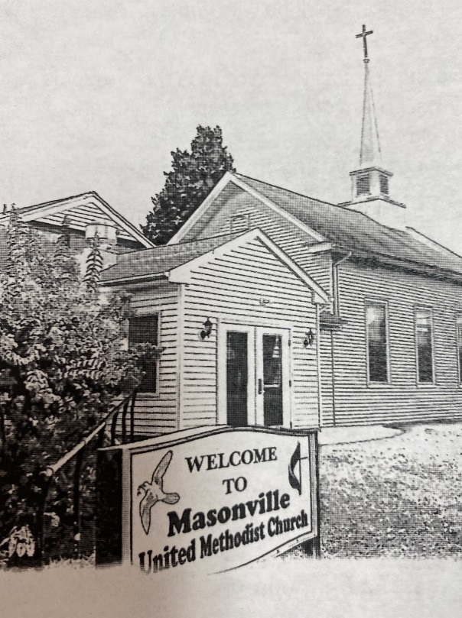

Rev. Karen Murray, Pastor
Cell # 856-266-0083

Mike Gerety, Musician
Shirley Bootsma, Choir Director
Wendy Smith, Administrative Assistant

Website: www.masumc.org
Or Email: mumc07@live.com
CCLI# 13777290

