April 21, 2024
9:30 AM Worship Service
Fourth Sunday after Easter

*Musical Prelude:
Welcome and Announcements

Entrance Song: Guide Me, O Thou Great Jehovah UMH #127
Guide me, O thou great Jehovah, pilgrim through this barren land.
I am weak, but you art mighty; hold me with thy powerful hand.
Bread of heaven, bread of heaven,
Feed me till I want no more; feed me till I want no more.

Open now the crystal fountain, whence the healing stream doth flow;
Let the fire and cloudy pillar lead me all my journey through.
Strong deliverer, strong deliverer,
Be thou still my strength and shield; be thou still my strength and shield.

When I tread the verge of Jordan, bid my anxious fears subside;
Death of death and hell's destruction, land me safe on Canaan's side.
Songs of praises, songs of praises,
I will ever give to thee; I will ever give to thee.

Call to Worship: Lay Reader: Tom Schulz
L: How shall we live when we have more than enough?
P: We have no greater praise to offer than caring for your creatures and Creation.
L: The earth is our teacher – nurturing and tender.
P: In this hour, O God, nourish us in the soil of your love.
L: Let us worship God, the Ground of all Being.
(Written by Rev. Paul Mitchell, Walla Walla, WA)

Song of Praise: His Name Is Wonderful UMH #174
His name is wonderful, his name is wonderful,
His name is wonderful, Jesus, my Lord.
He is the mighty King, Master of everything;
His name is wonderful, Jesus, my Lord.
He’s the great Shepherd, the Rock of all ages, almighty God is he;
Bow down before him, love and adore him,
His name is wonderful, Jesus, my Lord.

Opening Prayer:
Living Word, whose love abides in us, You call us to love in truth and action. Give courage to our hearts so we may love your beloveds. Open our ears to the wisdom of those you send, who might otherwise be dismissed. Transform our charity into justice over all the earth. Amen. (Written by Rev. Laurie Bayen and Rev. Laura Baumgartner.)

Opening Hymn: Great Is Thy Faithfulness UMH #140
Great is thy faithfulness, O God my Father;
There is no shadow of turning with thee;
Thou changest not, thy compassions, they fail not;
As thou hast been, thou forever wilt be.

Refrain: Great is thy faithfulness! Great is thy faithfulness!
Morning by morning new mercies I see;
All I have needed thy hand hath provided;
Great is thy faithfulness, Lord, unto me!

Summer and winter and springtime and harvest,
Sun, moon, and stars in their courses above
Join with all nature in manifold witness
To thy great faithfulness, mercy, and love. Refrain:

Pardon for sin and a peace that endureth,
Thine own dear presence to cheer and to guide;
Strength for today and bright hope for tomorrow,
Blessings all mine, with ten thousand beside! Refrain:

Responsive Reading: Psalm 23 UMH #754
The Lord is my shepherd; I shall not want.
The Lord makes me lie down in green pastures,
Leads me beside still waters, restores my life,
Leads me in right paths for the sake of the Lord’s name.
Even though I walk through the darkest valley, I fear not evil;
For you are with me; your rod and your staff, they comfort me.
You prepare a table before me in the presence of my enemies;
You anoint my head with oil, my cup overflows.
Surely goodness and mercy shall follow me all the days of my life;
And I shall dwell in the house of the Lord as long as I live.

Pass the Peace
Wiggle Time/Noisy Coin

Offering
Doxology UMH #95

Offertory Prayer:
Scripture: 1 John 3:16-24
Message: “We Abide In Christ” Rev. Karen Murray

Prayer Chorus: Cares Chorus TFWS #2215
I cast all my cares upon you,
I lay all of my burdens down at your feet,
And anytime that I don’t know what to do,
I will cast all my cares upon you.

Pastoral Prayer:
The Lord's Prayer:

Closing Hymn: Savior, Like a Shepherd Lead Us UMH #381
Savior, like a shepherd lead us, much we need thy tender care;
In thy pleasant pastures feed us, for our use thy folds prepare.
Blessed Jesus, blessed Jesus! Thou hast bought us, thine we are.
Blessed Jesus, blessed Jesus! Thou hast bought us, thine we are.

We are thine, thou dost befriend us, be the guardian of our way;
Keep thy flock, from sin defend us, seek us when we go astray.
Blessed Jesus, blessed Jesus! Hear, O hear us when we pray.
Blessed Jesus, blessed Jesus! Hear, O hear us when we pray.

Thou hast promised to receive us, poor and sinful though we be;
Thou hast mercy to relieve us, grace to cleanse and power to free.
Blessed Jesus, blessed Jesus! We will early turn to thee.
Blessed Jesus, blessed Jesus! We will early turn to thee.

Early let us seek thy favor, early let us do thy will;
Blessed Lord and only Savior, with thy love our bosoms fill.
Blessed Jesus, blessed Jesus! Thou hast loved us, love us still.
Blessed Jesus, blessed Jesus! Thou hast loved us, love us still.

Benediction

Sending Forth: Go In Love
Go in love. Have no fear, God will guide you, He is always near.
Go in love. Take his hand. God will hear you, He will understand.
May his light forever shine upon you; May his peace be always in your heart.
Go in love, face each day. God will lead you, He will show the way.
Go in love and live in faith.

Postlude

Last week’s offering received $1,067.50 In person attendance last week: 46
Masonville-Rancocas United Methodist Church
200 Masonville Rd.
Mt. Laurel, New Jersey 08054
(856) 234-0941

"We are a Christ-Centered Church reaching out to the world transforming lives for the Glory of God.”

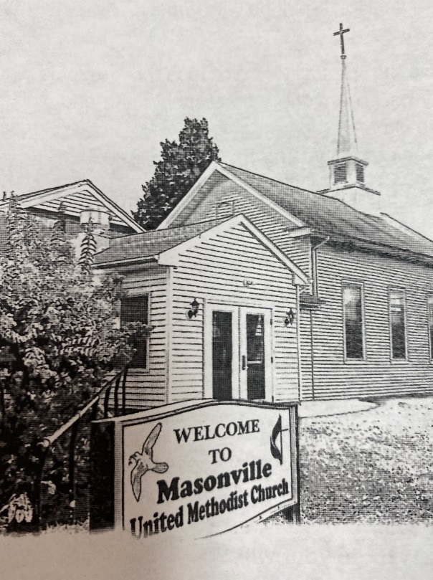

Rev. Karen Murray, Pastor
Cell # 856-266-0083

Mike Gerety, Musician
Shirley Bootsma, Choir Director
Wendy Smith, Administrative Assistant

Website: www.masumc.org
Or Email: mumc07@live.com
CCLI# 13777290

