Masonville-Rancocas UMC
200 Masonville Road, Mount Laurel, NJ 08054
FOURTH SUNDAY AFTER THE EPIPHANY
COMMUNION SUNDAY
1st February 2026 - 9:30AM

***Please Stand If Able

Please take this time to prepare your prayer requests. Prayer slips can be found in the pews.

Musical Prelude:
Welcome and Announcements

***Call to Worship: Lay Reader: Charlotte Elbertson
L: Beloved, what worship does God desire of us?
P: To do justice, love kindness, and live humbly with God.
L: In our life together as the body of Christ, what worship does God desire of us?
P: To do justice, love kindness, and live humbly with God.
L: When we share the good news with all creation, what worship does God desire of us?
P: To do justice, love kindness, and live humbly with God.
L: Come, let us worship God with justice, kindness, and humility!
P: We come to worship God with our voices and our lives. Thanks be to God! Amen.

***Song of Praise: Shout to the Lord TFWS#2074
My Jesus, my Saviour, Lord, there is none like you;
All of my days I want to praise the wonders of your mighty love.
My comfort, my shelter, tower of refuge and strength,
Let every breath, all that I am, never cease to worship you.

Shout to the Lord, all the Earth,
Let us sing power and majesty, praise to the King.
Mountains bow down and the seas will roar at the sound of your name.
I sing for joy at the work of your hands,
Forever I'll love you, forever I'll stand.
Nothing compares to the promise I have in you.

***Opening Prayer in Unison:
Oh God, Our Creator, Redeemer, Sustainer- How do we thank you? How do we show our gratitude? Do you want signs and sacrifices? Do you want gold and cattle? Can we turn our children over to you? Would that repay our debt and make everything right? Tell us, what do you require in return for all your goodness? Oh God, our teacher, example, companion— You have shown us what is good and call us to remember that what you require is not repayment of debt or settling the score, but obedience. Show us, God, when to do justice, how to love kindness, and where to walk, humbly, with you. Amen.

***Opening Hymn: To God be the Glory UMH #98

Pass the Peace
Prayer request slips will be collected during the singing of the prayer chorus.

Prayer Chorus: Just a Closer Walk with Thee TFWS# 2158

Pastoral Prayer:

Wiggle Time/Noisy Coins
Tithes and Offerings
***Doxology UMH #95

***Offertory Prayer in Unison:
God of Justice and Mercy, you do not ask for thousands of offerings or rivers of oil, only that we live with love, humility, and a hunger for what is right. Accept these gifts we bring—not as bargaining chips, but as signs of our desire to follow you. Use them and us to pour out kindness where the world is aching, to walk alongside the weary, and to bring your healing presence into troubled places. May our giving be our “yes” to your call, our response to your grace, and our witness to your hope. In Jesus’ name we pray. Amen.

***Scripture: Matthew 5:1-12
Message: “The Teaching of Christ: Beatitudes” Rev. Raj Mutnal

Communion:

And now let us prepare our hearts to receive Holy Communion.

INVITATION

The Lord be with you.
And also with you.
Lift up your hearts.
We lift them up to the Lord.
Let us give thanks to the Lord our God.
It is right to give our thanks and praise.

And so, with your people on earth and all the company of heaven we praise Your name and join their unending hymn:

Holy, holy, holy Lord, God of power and might,
heaven and earth are full of your glory. Hosanna in the highest.
Blessed is he who comes in the name of the Lord. Hosanna in the highest.

And so, in remembrance of these your mighty acts in Jesus Christ, we offer ourselves in praise and thanksgiving as a holy and living sacrifice, in union with Christ's offering for us, as we proclaim the mystery of faith.
Christ has died; Christ is risen; Christ will come again.

The Lord’s Prayer:

Receive Communion:

Let Us Pray:
Eternal God, we give you thanks for this holy mystery in which you have given yourself to us. Grant that we may go into the world in the strength of your Spirit, to give ourselves for others, in the name of Jesus Christ our Lord. Amen.

***Closing Hymn: Be Thou My Vision UMH #451

Closing Prayer and Benediction:

***Sending Forth: Go In Love

Postlude

Lectionary for the week: Micah 6:1-8; Psalm 15;
1 Corinthians 1:18-31; Matthew 5:1-12

February Birthdays: 5 Dami Odebiyi; 5 Dara Odebiyi; 6 William Conover; 13 Bonnie Stinger; 13 Judy McAdoo; 15 Steve Immanuel;
17 Barbara Weatherwalks; 21 Abigail Marker; 23 Cindy Uhl; 27 Tom Schulz; 28 Wilma “Denise” Potts
Masonville-Rancocas United Methodist Church
200 Masonville Rd.
Mt. Laurel, New Jersey 08054
(856) 234-0941

"We are a Christ-Centered Church reaching out to the world transforming lives for the Glory of God.”

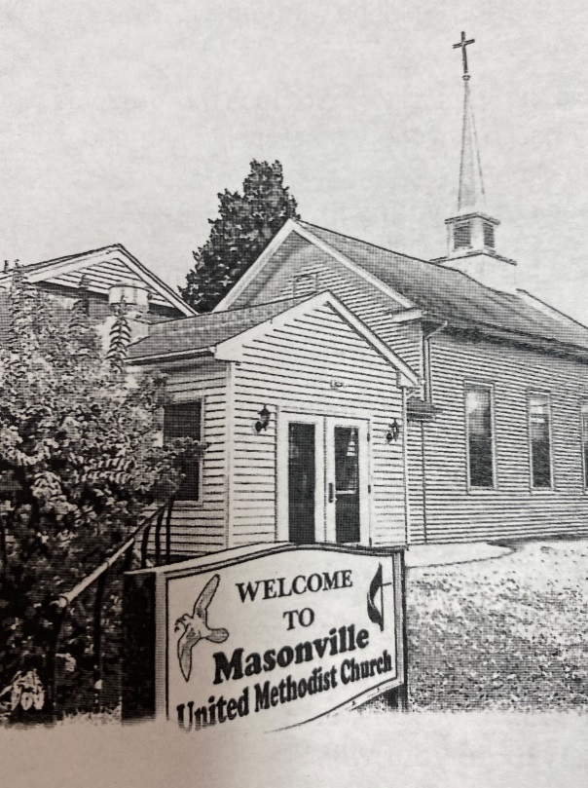

Rev. Raj Mutnal
Cell # 1(201) 920-3405

Mike Gerety, Musician
Wendy Smith, Administrative Assistant

Website: www.masumc.org
Or Email: mumc07@live.com
CCLI# 13777290

